Altitude Dependent Thrust and Rotor Configuration
This proposal outlines the development of an altitude-dependent thrust calculation model for the drone simulator. The primary objective is to create a realistic simulation that accurately considers changes in atmospheric conditions with varying altitudes, impacting the overall thrust required for stable flight.

Atmospheric Density Calculation:
The air density (ρ) will be calculated using the ideal gas law:
ρ = P / (R * T)
Where:
- P is the atmospheric pressure,
- R is the specific gas constant for dry air,
- T is the absolute temperature.

Altitude-Dependent Thrust Calculation:
The overall thrust force (F_{(net)}​) required for the drone is given by the equation:
F_{(net)}​ ​= m*g + (1/2)​ * Cd​ * A * (P / (R * T))​ * v²
Where:
- m is the mass of the drone,
- g is the acceleration due to gravity,
- Cd​ is the drag coefficient,
- A is the reference area (cross-sectional area),
- P is the atmospheric pressure,
- R is the specific gas constant for dry air,
- T is the absolute temperature,
- v is the velocity of the drone.

Pressure and Temperature variation:
The variation in pressure and temperature with respect to altitude is described by the International Standard Atmosphere (ISA) model, which is a standard way of representing the Earth's atmospheric properties. It's important to note that actual atmospheric conditions can deviate from the ISA model due to factors like weather patterns, but the ISA provides a useful reference.

Pressure Variation:
The pressure decreases exponentially with altitude. The general equation for pressure in the ISA model is:
P = P₀​(1 – (​L*h/T₀)​) ^{(g*M/R*L)}​
Where:
- P is the pressure at altitude h,
- P₀​ is the sea-level standard atmospheric pressure,
- L is the temperature lapse rate,
- h is the altitude,
- T₀ is the sea-level standard temperature,
- g is the acceleration due to gravity,
- M is the molar mass of Earth's air,
- R is the specific gas constant for dry air.

Temperature Variation:
The temperature lapse rate (L) is the rate at which temperature decreases with altitude. In the ISA, the temperature is assumed to decrease at a standard lapse rate, typically −6.5K/km. The general equation for temperature in the ISA model is:
T = T₀​ + (L*h)
Where:
- T is the temperature at altitude h,
- T₀​ is the sea-level standard temperature,
- L is the temperature lapse rate,
- h is the altitude.

Altitude Considerations:
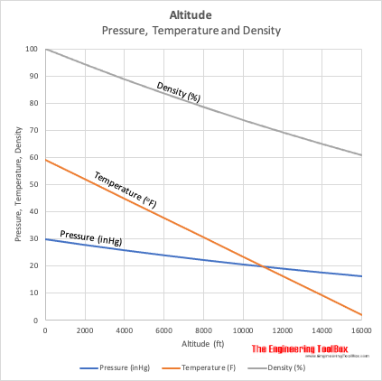
Figure 1https://www.engineeringtoolbox.com/air-altitude-temperature-d_461.html
Observations indicate that there is no significant change in pressure and temperature values up to 1000 feet. Therefore, for altitudes below this threshold, the original thrust equation may be applicable without considering altitude-dependent variations.
F_{(net)}​ ​= m*g + (1/2)​ * Cd​ * A * (P / (R * T))​ * v²

Legal regulations in most countries restrict drone flights to a maximum altitude of 400 feet. This constraint should be considered in simulations and real-world applications.

Rotor Configuration and Power Consumption:
Rotors and Orientation:
- Drones can have various configurations, including quadcopters (4 rotors), hex copters (6 rotors), octocopters (8 rotors), and more.
- Increasing the number of rotors generally provides more stability and lifting capacity but also increases power consumption.
- The placement of rotors on the drone frame influences stability and maneuverability.
- For quadcopters, the rotors are typically arranged in a "+" or "X" configuration. The "+ " configuration is often used for simplicity, while the "X" configuration allows for more aerodynamic symmetry.
- The orientation of the rotors (clockwise or counterclockwise) affects the drone's rotational stability.
- To counteract the torque generated by the spinning rotors, drones often have opposing rotors spinning in opposite directions. For example, if one rotor spins clockwise, the rotor diagonally opposite might spin counterclockwise.
- Some advanced drones use thrust vectoring, where the direction of thrust can be dynamically adjusted. This allows for improved control and stability, especially during maneuvers.
Rotor Size and Pitch:
- Larger rotor sizes typically require more power to generate lift, but they can be more efficient in certain conditions. The pitch of the rotor blades influences power requirements.
- The pitch of the rotor blades also influences the efficiency of the rotor in different flight conditions.
Rotor Efficiency and Speed:
- Well-designed rotor blades and higher motor efficiency contribute to lower power consumption. The rotational speed of the rotors influences power needs.
Aerodynamic Interactions:
- Proper spacing and orientation of rotors minimize interference and optimize overall efficiency, impacting power consumption.

​

